SWE30008 Software Team Project, Semester 1 2015

Internet of Things (ESP8266)

Project Plan

*TEAM 10*

[7242794@student.swin.edu.au](mailto:Names:7242794@student.swin.edu.au) Edward Francis Gilbert 0434 846 690 (Team leader)

[9718168@student.swin.edu.au](mailto:9718168@student.swin.edu.au) Adam De Blasio 0430 737 112

[664306x@student.swin.edu.au](mailto:664306x@student.swin.edu.au) Luke Jackson 0421 464 381

[7440103@student.swin.edu.au](mailto:7440103@student.swin.edu.au) Edwin Wong 0416 160 155

**Table 1. Document Change Control**

|  |  |  |  |
| --- | --- | --- | --- |
| Version | Date | Authors | Summary of Changes |
| 0.1 | 14/3/15 | Edward | Drafted sections 1 to 2.1 |
| 0.2 | 16/3/15 | Edward | Drafted section 2 |
| 0.3 | 18/3/15 | Edward | Drafted section 3 |
| 0.4 | 19/3/15 | Edwin | Added hourly rates |
| 0.5 | 22/3/15 | Luke, Edward | Added scheduling |
| 0.6 | 23/3/15 | Edward | Added all other sections, finalized document |

**Table 2. Document Sign Off**

|  |  |  |  |
| --- | --- | --- | --- |
| Name | Position | Signature | Date |
|  |  |  |  |
|  |  |  |  |
|  |  |  |  |
|  |  |  |  |

**Client Sign off**

|  |  |  |  |
| --- | --- | --- | --- |
| Name | Position | Signature | Date |
|  |  |  |  |

Table of Contents

2 Introduction 4

2.1 Background 4

2.2 Key Project Personnel 4

2.2.1 Client - Dr James Hamlyn-Harris 4

2.2.2 Other Stake holders 4

2.2.3 Project Supervisor, Team Leader and Key Project Members 5

3 Terms of Reference 7

3.1 Objectives 7

3.2 Scope 7

3.3 Critical Success Factors 8

3.4 Acceptance Criteria 8

4 Establishment 9

4.1 Processes, Procedures and Standards 9

4.1.1 Software development method 9

4.1.2 Project Environment 10

4.1.3 Project Team Skill Development Requirements 11

4.2 Deliverables, Activities and Capital Resources 12

4.2.1 Deliverables 12

4.2.2 Activities 12

4.2.3 Resources 12

5 Organisation and Structure 13

6 Risks 14

7 Schedule 14

7.1 Project Time Line 14

7.2 External Dependencies 14

7.3 Assumptions 14

8 Budget 15

9 References 15

10 Appendix A – Risk Assessment 17

11 Appendix B – Project Scheduling 20

# Introduction

## Background

As the final subject of their degree, Bachelor of ICT students at Swinburne must complete a capstone project, where a team of students must fulfil a client brief over the course of a semester. Students majoring in the Network Design and Security specialisations are offered projects specific to their field, with Dr James Hamlyn-Harris of the Department of Computer Science & Software Engineering posing as the client. This is one of the projects offered as part of this initiative.

## Key Project Personnel

The key personnel involve in this project are as follows:

### Client - Dr James Hamlyn-Harris

Dr James Hamlyn-Harris is Deputy Chair of the Department of Computer Science & Software Engineering, and a Senior Lecturer in the Faculty of Science, Engineering and Technology at Swinburne University of Technology. Dr Hamlyn-Harris teaches in the fields of IT Security, Internet Security and Technical Software Development, and researches in the fields of Computer Security, Virtualisation and Testing.

##### ****Contact Details:****

*Location:* Hawthorn campus, Room EN507a

*Email:* [jhamlynharris@swin.edu.au](mailto:jhamlynharris@swin.edu.au)

*Phone:*03 9214 8672

### Other Stake holders

#### Swinburne University of Technology

Swinburne University of Technology is a tertiary institution with campuses throughout Melbourne, Australia and an additional campus at Sarawak, Malaysia.

**Representative – Louis Kellerman**

**Contact Details:**

***Location:* John Street, Hawthorn, Victoria**

***Email:*** [lkellerman@swin.edu.au](mailto:lkellerman@swin.edu.au)

***Phone:* 03 9214 4749**

### Project Supervisor, Team Leader and Key Project Members

#### Project Supervisor - Dr Rajesh Vasa

Dr Rajesh Vasa is a lecturer in the department of Computer Science and Software Engineering at Swinburne University of Technology. He is also Head of Research and Design at the Swinburne NICTA Software Innovation Lab at Swinburne.

##### Contact Details:

*Location:* Hawthorn campus, Room EN514b

*Email:* rvasa@swin.edu.au

*Phone:*03 9214 5011

0435 016 006

#### Team Leader - Edward Gilbert

*Secondary Role:* Testing

**Contact Details:**

*Email:* [7242794@student.swin.edu.au](mailto:7242794@student.swin.edu.au)

[edwardfrancisgilbert@outlook.com](mailto:edwardfrancisgilbert@outlook.com)

*Phone:* 0434 846 690

#### Lead Developer - Adam De Blasio

*Secondary Role:* Documentation

**Contact Details:**

*Email:* [9718168@student.swin.edu.au](mailto:9718168@student.swin.edu.au)

[adsmji@gmail.com](mailto:adsmji@gmail.com)

*Phone:* 0430 737 112

#### Lead Tester - Luke Jackson

*Secondary Role:* Developer

**Contact Details:**

*Email:* [664306x@student.swin.edu.au](mailto:664306x@student.swin.edu.au)

[luke.jackson@live.com.au](mailto:luke.jackson@live.com.au)

*Phone:* 0490 169 494

#### Lead Documentation - Edwin Wong

*Secondary Role:* Team Leader

**Contact Details:**

*Email:* [7440103@student.swin.edu.au](mailto:7440103@student.swin.edu.au)

[edwinwongcm@gmail.com](mailto:edwinwongcm@gmail.com)

*Phone:* 0416 160 155

# Terms of Reference

The goal of the project is to create a definitive guide to using and programming the ESP8266 module. The intended user group is adults with average literacy and numeracy, who have basic proficiency in one of the available programming languages for the module.

## Objectives

The following objectives have been identified for the project:

1. Identify a complete toolchain for accessing, flashing, programming and installing software on the ESP8266 module by Tuesday 24 March 2015.
2. Create a definitive guide to using and programming the ESP8266 module by Tuesday 26 May 2015, that achieves overall effectiveness, efficiency and satisfaction ratings of 75% or higher in user testing.
3. Complete a test report demonstrating the robustness of our software, by passing in full a comprehensive test plan of all of code to be included in the guide (Objective 1) by Tuesday 26 May 2015.
4. Deliver an informative presentation on the project to students and staff of the faculty on Tuesday 26 May 2015.
5. Deliver an informative A3 poster highlighting key aspects of the project to students and staff of the faculty by Tuesday 26 May 2015.

## Scope

The project commenced on Tuesday 3 March 2015, and will finish no later than Tuesday 26 May 2015. The scope of the project shall be limited to the objectives stated in Section 2.1 above, unless changes are made by mutual agreement of the client and the project team.

The following tasks and items must be addressed by the project:

* Easy (zero or minimal configuration) installation of the toolchain to Windows and Linux PCs.
* Provide guidance suitable for newcomers to the chosen programming language (though not programming), building circuits, and the ESP8266 device - sufficient that after following the guide they will have some confidence in being able to build other projects.

The following tasks and items are agreed as being outside of the scope of the project, although their exclusion is not necessarily mandatory and can be re-negotiated:

* Development of original tools as part of the toolchain (Objective 1).
* Development of original projects as part of the ESP8266 guide (Objective 2).

The scope of this project is flexible. If time allows, the scope of the project can be modified and extended if this is negotiated and agreed upon by both the client and the project team.

## Critical Success Factors

The following factors have been identified as critical to the success of the project:

1. The project must be completed by Tuesday 26 May 2015.
2. A tool chain must be identified for programming the ESP8266.
3. The guide (objective 2) must achieve overall effectiveness, efficiency and satisfaction ratings of 75% of higher based on user testing of the stated user group.

## Acceptance Criteria

The end product of the project (the guide to programming the ESP8266) shall be deemed acceptable if all of the critical success factors (section x.3) have been met.

# Establishment

## Processes, Procedures and Standards

### Software development method

The project team has chosen Disciplined Agile Delivery (DAD) as the basis for software development. This is a simplified variation of the Unified Process (UP) which aims to incorporate features of agile and lean software development methods. In particular, the project phases and goals of DAD have been adopted, as presented in Figure 1 below.

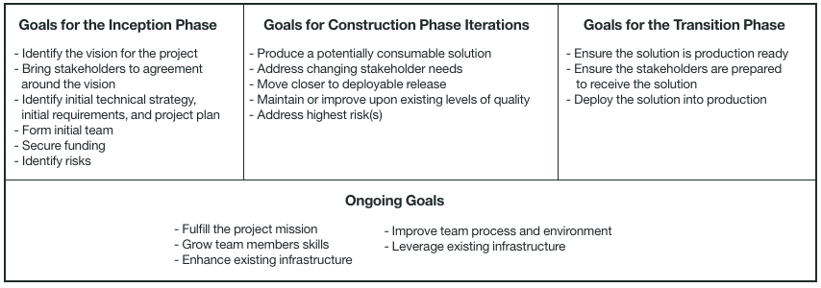

Figure 1 - Goals for phases of the Disciplined Agile Delivery model (Amber & Lines 2011)

Disciplined agile delivery was chosen as the model for the following reasons:

* Iterative development
* Simplified project phases compared to the Unified Process (UP) which better fit the project
* An explicit and continual focus on individual and team growth throughout the project
* The ability to include many of the beneficial practices of agile development easily
* Explicit treatment of risks

#### Other development standards

Development will also adhere to the following processes:

**User-Centred Design**

The project will make use of the User-centred design methodology in all stages of the project. The following features of User-centred design will be applied to the project:

* An early focus on users and tasks
* Empirical measurement of product usage
* Iterative design

**Version Control**

Use of the git version control system will be used for all code created within the project.

### Project Environment

#### Development and deployment

|  |  |
| --- | --- |
| **Work places** | Individual work environments  Group meetings - Study areas around Swinburne University of Technology - Hawthorn campus |
| **Computers** | Individual work stations/PCs |
| **User accounts** | *Email accounts* - Swinburne student email, individual email  *Microsoft One Drive* - one per team member  *Github* - one per team member, supervisor account  *Bitbucket* - one per team member, supervisor account |
| **Server accounts** | Github repository  Bitbucket repository  Microsoft One Drive shared folder |
| **Stationary** | Printer, ink and paper for user test surveys and forms |

Figure 2 - Environment concerns for development and deployment of the project

### Project Team Skill Development Requirements

As development is based on the Disciplined Agile Delivery (DAD) model (see section 4.1.1), growth of team member skills and organizational learning are central to the goals of the project. Team members have indicated their initial score for knowledge and skill areas relevant to the project in a self-assessment. This serves as a baseline for examining skill growth throughout the project, and as an adjunct when scheduling project tasks. This assessment is presented in Figure 3 below, and the scale is presented in Figure 4.

|  |  |  |  |  |
| --- | --- | --- | --- | --- |
| **Skill** | **Adam** | **Luke** | **Edwin** | **Edward** |
| Technical Writing | **2** | **3** | **3** | **4** |
| Guide/Tutorial writing | **2** | **3** | **2** | **2** |
| Programming (Lua) | **3** | **1** | **1** | **1** |
| Programming (C) | **3** | **2** | **3** | **2** |
| Programming (Assembly) | **2** | **2** | **2** | **1** |
| Unit testing | **3** | **3** | **3** | **2** |
| User Testing | **2** | **3** | **3** | **3** |
| Networking | **3** | **1** | **4** | **3** |
| Electronics | **3** | **1** | **1** | **1** |
| Soldering | **3** | **1** | **1** | **1** |
| ESP8266 | **2** | **1** | **1** | **1** |
| Arduino projects | **3** | **1** | **1** | **1** |
| Raspberry Pi project | **3** | **1** | **2** | **1** |
| Project Planning | **2** | **2** | **2** | **3** |
| Risk Assessment | **2** | **2** | **3** | **3** |

Figure 3- Team member self-assessment of relevant knowledge and skills

|  |  |  |
| --- | --- | --- |
| **Category Number** | **Category** | **Description** |
| **1** | **Beginner** | No prior exposure |
| **2** | **Introductory** | Limited experience in this area |
| **3** | **Intermediate** | Some experience and confidence in applying this knowledge/skill/technology |
| **4** | **Competent** | Knowledge/skill is approaching professional level |
| **5** | **Professional** | Professional experience |

Figure 4 - Rating system for knowledge and skill self-assessment

## Deliverables, Activities and Capital Resources

### Deliverables

* Toolchain for development on the ESP8266
* Definitive guide to programming the ESP8266
* Test report showing the successful testing (including user testing) of the project guide material
* Presentation
* Poster

### Activities

A sequential list of activities for the project is presented below:

* 1. Form initial team
  2. Identify project vision and requirements
  3. Identify initial technical solution
  4. Create test plans

2.1.1, 2.2.1, 2.3.1 Produce a potentially consumable solution

2.1.2, 2.2.1, 2.3.1 User testing

2.1.3, 2.2.3, 2.3.3 Analysis and review

2.1.4, 2.2.4, 2.3.4 Address Knowledge, Skill and Technology (KoST gaps)

2.1.5, 2.2.5, 2.3.5 Adjust project planning

3.1 Presentation

3.2 Poster

3.3 Deliver product to client

3.4 Project review

3.5 Maintenance

### Resources

* *Space for user testing* – common areas of Swinburne campus
* *Equipment:*
  + USB-serial adaptor (minimum of 1, one per chip is desirable)
  + ESP8266-based chipsets (minimum of 1, one per team member is desirable)
  + Male-female jumper cables (minimum of 4 per chip/USB-serial adaptor pair)
  + Other parts and equipment as required - to be determined over the course of the project (may include: breadboards, jumper cables, buttons, LED lights, sensors).

# Organisation and Structure

The following groups will be participating in the project:

* Client
* Swinburne University of Technology (Faculty of Science, Engineering and Technology)
* Project team
* Users

A matrix structure identifying the groups involved in each activity is presented in Figure 5 below.

|  |  |  |  |  |  |
| --- | --- | --- | --- | --- | --- |
| Deliverables  Activities | Toolchain | Guide | Test report | Presentation | Poster |
| 1.1 Form initial team |  |  |  |  |  |
| 1.2 Identify project vision and requirements |  | Team  Client |  |  |  |
| 1.3 Identify initial technical solution | Team  Client |  |  |  |  |
| 1.4 Create test plans |  | Team |  |  |  |
| 2.1.1, 2.2.1, 2.3.1 Produce a potentially consumable solution |  | Team | Team |  |  |
| 2.1.2, 2.2.1, 2.3.1 User testing |  | Team  Users | Team  Users |  |  |
| 2.1.3, 2.2.3, 2.3.3 Analysis and review |  | Team |  |  |  |
| 2.1.4, 2.2.4, 2.3.4 Address Knowledge, Skill and Technology (KoST gaps) |  | Team |  |  |  |
| 2.1.5, 2.2.5, 2.3.5 Adjust project planning |  | Team |  |  |  |
| 3.1 Presentation |  |  |  | Team  University |  |
| 3.2 Poster |  |  |  |  | Team  University |
| 3.3 Deliver product to client |  |  |  | Team  Client |  |
| 3.4 Project review |  |  |  | Team |  |
| 3.5 Maintenance |  | Team  Client |  |  |  |

Figure 5 - Matrix of groups and deliverables involved per project activity

# Risks

Risks to the project have been identified and ranked according to their potential severity. Mitigation and contingency planning was then performed for each risk. This work is presented in Appendix A.

# Schedule

## Project Time Line

A full project schedule is included in Appendix B.

## External Dependencies

* The client is only available for a limited number of meetings (approximately 5) throughout the project. A meeting time of 12:30 on Tuesdays has been arranged, with meetings scheduled on request.
* Team members have other work and commitments. Availability per team member has been estimated at 2 hours per working day (Monday – Friday).

## Assumptions

The following assumptions have been made in scheduling the project:

* Allocated person-hours per task (as scheduled) will be approximately sufficient for their completion.
* Team members will be available for approximately 10 hours of work each week per member.

# Budget

Personnel cost has been calculated as an hourly rate, based on the average wage for a graduate in that role (Payscale 2015). This is presented in Figure 6.

|  |  |  |
| --- | --- | --- |
| **Name** | **Primary Role** | **Rate per Hour** |
| Edward Gilbert | Team Leader | $28 |
| Adam Di Blasio | Lead Developer | $21 |
| Luke Jackson | Lead Tester | $20 |
| Edwin Wong | Lead Documentation | $20 |

Figure 6 - Hourly rate for project team members

The projected budget for the project work tasks and activities is presented in Figure 7.

The total cost of the project is estimated at **$3455.68**.

# References

Ambler, S & Lines, M, 2011, *Disciplined Agile Delivery: An Introduction,* viewed 21/3/2015, <public.dhe.ibm.com/common/ssi/ecm/en/raw14261usen/RAW14261USEN.PDF>

Payscale, *Salary Search: Job,* Viewed 19/3/2015, <http://www.payscale.com/research/AU/job>

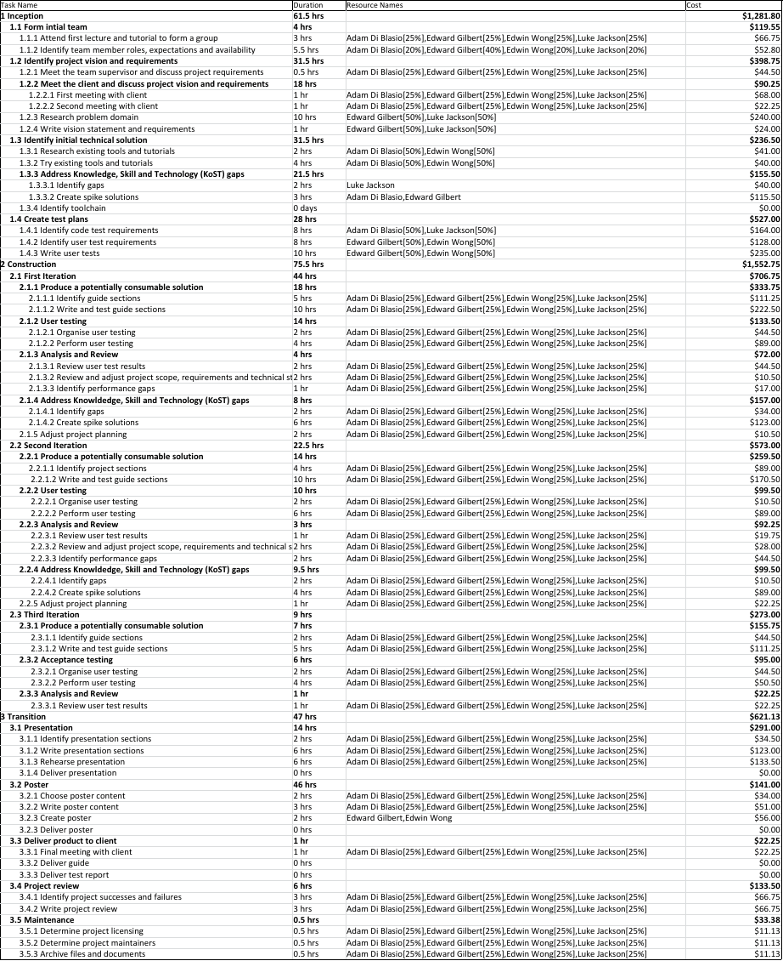

Figure 7 - Budget per project task, activity and phase

# Appendix A – Risk Assessment

Figure 8, 9, 10 & 11 - Risk matrix, description of risk levels, Category keys for likelihood and impact

|  |  |  |  |
| --- | --- | --- | --- |
|  | **Impact** | | |
| **Likelihood** | ***L*** | ***M*** | ***H*** |
| ***L*** | **Low** | **Low** | **Medium** |
| ***M*** | **Low** | **Medium** | **High** |
| ***H*** | **Medium** | **High** | **Very High** |

|  |  |
| --- | --- |
| **Risk Level** | **Description** |
| ***Low*** | The project will be relatively unaffected by this outcome, or it is unlikely to occur and treatment of the risk is not economically viable. |
| ***Medium*** | There will be some impact on the project. Changes to the project schedule and minor changes in scope are predicted. |
| ***High*** | The project will be significantly impacted overall, with moderate changes predicted to the schedule and scope. |
| ***Very High*** | The project is not feasible in its current form, and will require major changes to the requirements and scope in order to proceed. |

|  |  |  |
| --- | --- | --- |
| **Category** | **Description** | **Estimated Probability, P** |
| ***L*** | Low - there is a small chance that this risk will occur within the duration of the project. | (P <= 0.15) |
| ***M*** | Medium - there is a moderate chance that this risk will occur within the project. | (0.15 < P <= 0.5) |
| ***H*** | High - There is a high chance that this risk will occur within the duration of the project. | (0.5 < P <= 1) |

|  |  |  |
| --- | --- | --- |
| **Category** | **Description** | **Estimated Impact (Loss of available hours h)** |
| ***L*** | Low - Occurance of this risk will have a small impact on the schedule of the project. | h < 20 |
| ***M*** | Medium - Occurance of this risk will have a moderate impact on the schedule of the project. | 20 < h <= 60 |
| ***H*** | High - This risk could have a significant impact on the schedule of the project. | h > 60 |

Table 1 - Project risks listed in order of severity

|  |  |  |  |  |  |  |
| --- | --- | --- | --- | --- | --- | --- |
| **Risk No.** | **Risk** | **Likelihood** | **Impact** | **Rating** | **Mitigation Strategy** | **Contingency Plan (see table)** |
| **1** | Communication breakdown within the team | L | H | **Medium** | Encourage participation and constructive feedback. Make decisions by consenus. Follow up on any miscommunication to prevent any future problems. | A |
| **2** | Communication breakdown with the client | L | H | **Medium** | Maintain a professional relationship at all times. Keep in contact with the client frequently. | A |
| **3** | Communication breakdown with the team supervisor | L | H | **Medium** | Maintain a professional relationship at all times. Keep in contact with the team supervisor frequently. | B |
| **4** | Unsatisfactory performance by a team member | M | M | **Medium** | Make sure weekly work tasks and requirements are communicated clearly. Address any shortfalls quickly to prevent the situation from escalating unnecessarily. | C |
| **5** | Internal disagreement over a major project decision | M | M | **Medium** | Encourage participation and constructive feedback. Canvas opinions and alternatives wherever possible. Make decisions by consensus. | D |
| **6** | Knowledge, skill or technology gaps delay the project | M | M | **Medium** | Identify potential knowledge, skill and technology gaps often as part of the project workflow. Make use of spikes and spike solutions to bridge gaps as they are identified. | E |
| **7** | Project scope found to be not feasible | L | H | **Medium** | Ensure the project inception is adequately resourced with time and personnel. Address any uncertainties early in the project. | F |
| **8** | Permanent loss of one or more members of the team | L | H | **Medium** | N/A | F |
| **9** | Temporary loss of one of more members of the team | M | M | **Medium** | N/A | G |
| **10** | Loss of data | L | H | **Medium** | Make use of redundant cloud services for documentation and revision control. Maintain local copies. | H |
| **11** | Project fails final acceptance testing | M | L | **Low** | Conduct user testing throughout the project, to ensure user aims and desires are being addressed. | I |
| **12** | Project is completed ahead of schedule | M | L | **Low** | N/A | J |

Table 2 - Table of contingencies

|  |  |
| --- | --- |
| **Strategy Number** | **Description** |
| **A** | Identify the problem. Call a meeting to address the situation and determine causal factors. Bring the matter to the team supervisor's attention and seek further guidance. As a last resort, contact the unit convenor. |
| **B** | Identify the problem. Call a meeting with the team supervisor to address the situation and determine causal factors. As a last resort, contact the unit convenor. |
| **C** | Notify the team member formally about the issue and raise it for discussion at the next team meeting. Attempt to identify causal factors with the team member, and reschedule work as necessary. If problem is still unresolved, contact the team supervisor for further guidance. |
| **D** | Call a meeting to address the disagreement. Let all members state their reasoning for or against the possible actions, and then take a vote. Contact the team supervisor, and then the unit convenor for arbitration if still unresolved. |
| **E** | Use any slack time for the project to push back the schedule. Raise the issue with the team supervisor and seek their input. Address the gaps with spike solutions. Contact the client to re-negotiate the project scope if necessary. |
| **F** | Contact the team supervisor immediately to notify them of the situation and seek further guidance. Seek a meeting with the client to organise a change in scope. Re-allocate existing work to secondary members of that role, and other roles as necessary. |
| **G** | Re-allocate work to available team members, and adjust project schedule as necessary. |
| **H** | Re-check that the data is not recoverable. Identify last copies of data to work from. |
| **I** | Ask the client for acceptance with some minor alterations, based on results of previous testing. |
| **J** | Notify the client and arrange an appropriate extension to the project scope. |

# Appendix B – Project Scheduling

